**P6 – Design a Solution**

I will be designing a solution to the first scenario, in which an interior decorator needs a program to calculate painting a room would cost.

Form design:  
The form will need text boxes to enter all of the information, such as the room dimensions and the paint type. The user can then press a button to calculate and display the costs. Here is a mock-up of what the form might look like:

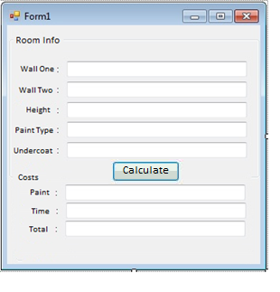

|  |  |  |
| --- | --- | --- |
| **Variable name** | **Purpose** | **Data Type** |
| wallOne | The length of wall one, as given by the user, to be used in calculating the area | Integer |
| wallTwo | The length of wall two, as given by the user, to be used in calculating the area | Integer |
| height | The height of the room, as given by the user, to be used in calculating the area | Integer |
| paintType | The type of paint, defined by the user | String |
| undercoat | The user can select the option to have an undercoat of paint | Boolean |
| Area | The total area of the walls, calculated from wallOne, wallTwo and height. | Integer |
| time | The time it will take to paint the room, calculated from the area | Floating point |
| paintCost | The cost of the paint | Floating point |
| timeCost | The cost of paying the painter | Floating point |
| totalCost | The total cost of painting the room | Floating point |